

Teacher Profile

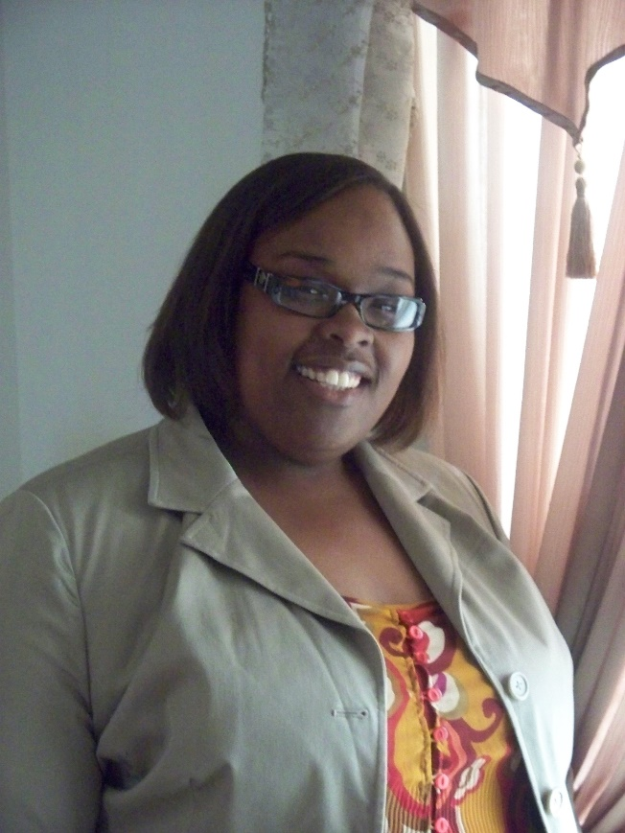

**Biography:**

Hello, my name is Tashona. I am 34 years old, and have loved teaching since I was a little girl. I come from a family of educators. My father is a classroom teacher, and all of his sisters are also school teachers.

The ability to help students access the world through new information, insight and creativity has been my passion and my greatest joy. This led to my journey in the field of education, and continues to spark my enthusiasm.

It is my hope that the students I teach, love for learning English is expanded, and that they are able to acquire this new knowledge in a way that combines both creativity and critical thinking. At the end of the day, I want them to love learning as a result of being in class with me.

Tashona Marshall

**Hometown:**

Chicago, IL USA

**Education:**

Graduated 2002 from

North Central College, Naperville, IL

BA Elementary Education

Graduated 2006 from

University of Northern Iowa, Cedar Falls, IA

MAE Educational Leadership

**Teaching Background:**

* Over 10 years teaching experience

Math, Reading and Social Studies